KOTAK BIZLABS ACCELERATOR PROGRAMME
ROADSHOW IN AMARAVATI
EVENT REPORT | 31 JANUARY 2025
DATE  31 January 2025 | VENUE  Vignan TBI, N Block, 2nd Floor | PROGRAMME FOCUS  Accelerator, grants and market access

1. Introduction
The Kotak BizLabs Accelerator Programme Roadshow in Amaravati was held on 31 January 2025 at Vignan Technology Business Incubator (Vignan TBI), N Block, 2nd Floor, Vignan’s University, Vadlamudi, Guntur. The roadshow introduced participants to the Kotak BizLabs Accelerator Programme and its opportunities for early-stage startups.
The programme served as an awareness and engagement platform for entrepreneurs, innovators and aspiring founders to learn about accelerator support, grant opportunities, investor networks and market access. It also highlighted the role of ecosystem partnerships in helping startups understand support pathways for business development.

2. Event Details
Event | Kotak BizLabs Accelerator Programme – Roadshow in Amaravati
Date and time | 31 January 2025 | 10:00 AM
Venue | Vignan TBI, N Block, 2nd Floor, Vignan’s University (Deemed to be University), Vadlamudi, Guntur
Organising organisation | Kotak Mahindra Bank / Kotak BizLabs
Ecosystem partners | T-Hub and Vignan TBI
Programme opportunity highlighted | Grants up to ₹15 lakh, investor network and market access, subject to eligibility and selection

3. Objectives of the Roadshow
- Introduce early-stage startups to the Kotak BizLabs Accelerator Programme.
- Build awareness of potential grant support and programme participation opportunities.
- Explain the value of investor networks and market access for startup growth.
- Encourage founders to assess their business models, customer needs and readiness for acceleration.
- Connect the local startup community with external entrepreneurship and innovation support organisations.

4. Programme Highlights

4.1 Kotak BizLabs Accelerator Programme
The roadshow presented Kotak BizLabs as a startup support initiative associated with Kotak Mahindra Bank. Participants were introduced to the programme’s support proposition, including the opportunity to access grants of up to ₹15 lakh, investor networks and market access. The availability of such support is dependent on programme criteria and selection.

4.2 Focus Sectors
The roadshow highlighted the following focus areas for startup innovation:
- EV / Mobility
- Agritech
- ClimateTech
- HealthTech
- FinTech
- Circular Economy
- EdTech
- Child and Maternal Health

4.3 Startup Readiness and Market Access
The programme drew attention to the importance of developing solutions around real customer needs, understanding the market opportunity and building a clear business proposition. Access to investor networks and market connections was presented as a way to help suitable startups progress towards stronger market readiness.
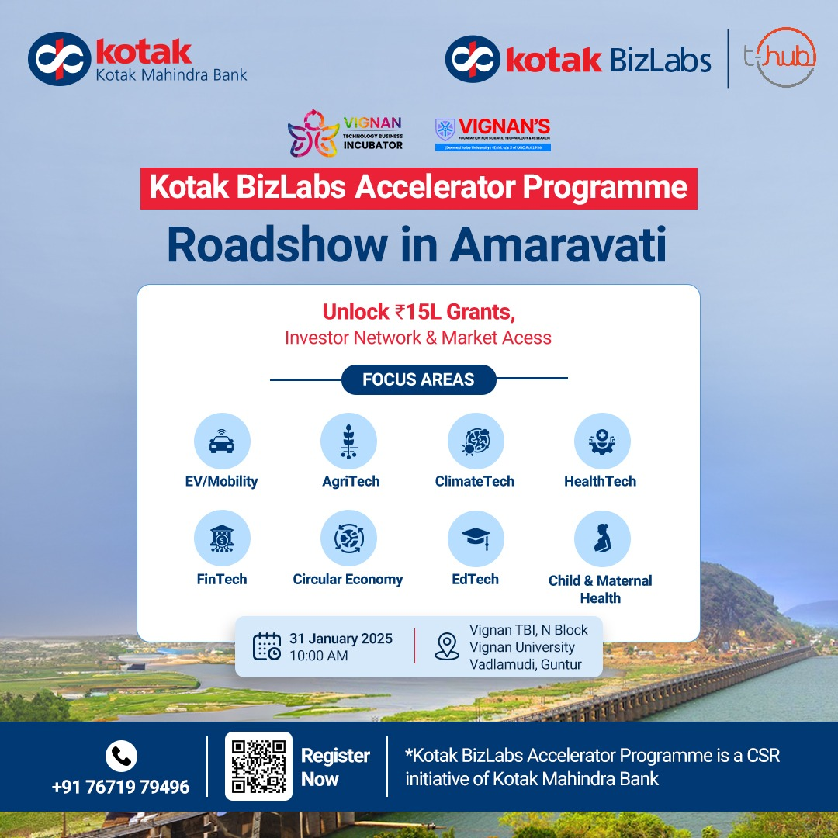

5. Participation and Engagement
The roadshow provided an opportunity for attendees to learn about the accelerator programme and its areas of focus. The event setting supported direct engagement around startup support, potential funding pathways and the importance of connecting promising ventures with appropriate ecosystem partners.

6. Key Outcomes
OUTCOME AREA | RESULT / SIGNIFICANCE
Accelerator awareness | Improved awareness of the Kotak BizLabs Accelerator Programme and the type of support it highlights.
Funding opportunity awareness | Participants were introduced to the programme’s grant opportunity of up to ₹15 lakh, subject to eligibility and selection.
Investor network exposure | The roadshow highlighted the potential value of investor connections for startups.
Market access focus | Participants were encouraged to consider customer access and routes to market as part of startup growth.
Sector awareness | The event communicated focus areas spanning mobility, agriculture, climate, healthcare, finance, circular economy, education and maternal health.
Ecosystem connection | The roadshow connected the startup support ecosystem around Kotak BizLabs, T-Hub and Vignan TBI.

7. Event Photographs
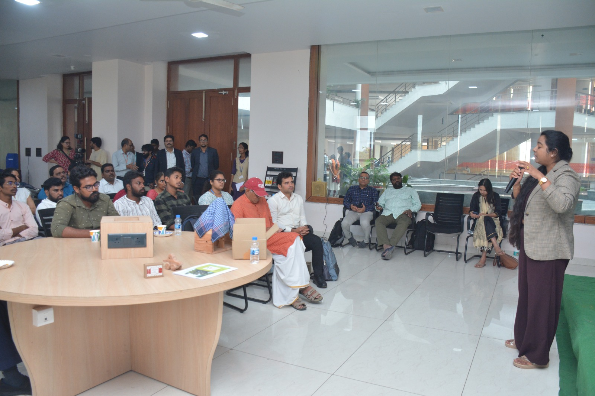
Interactive session during the Kotak BizLabs Accelerator Programme Roadshow at Vignan TBI.
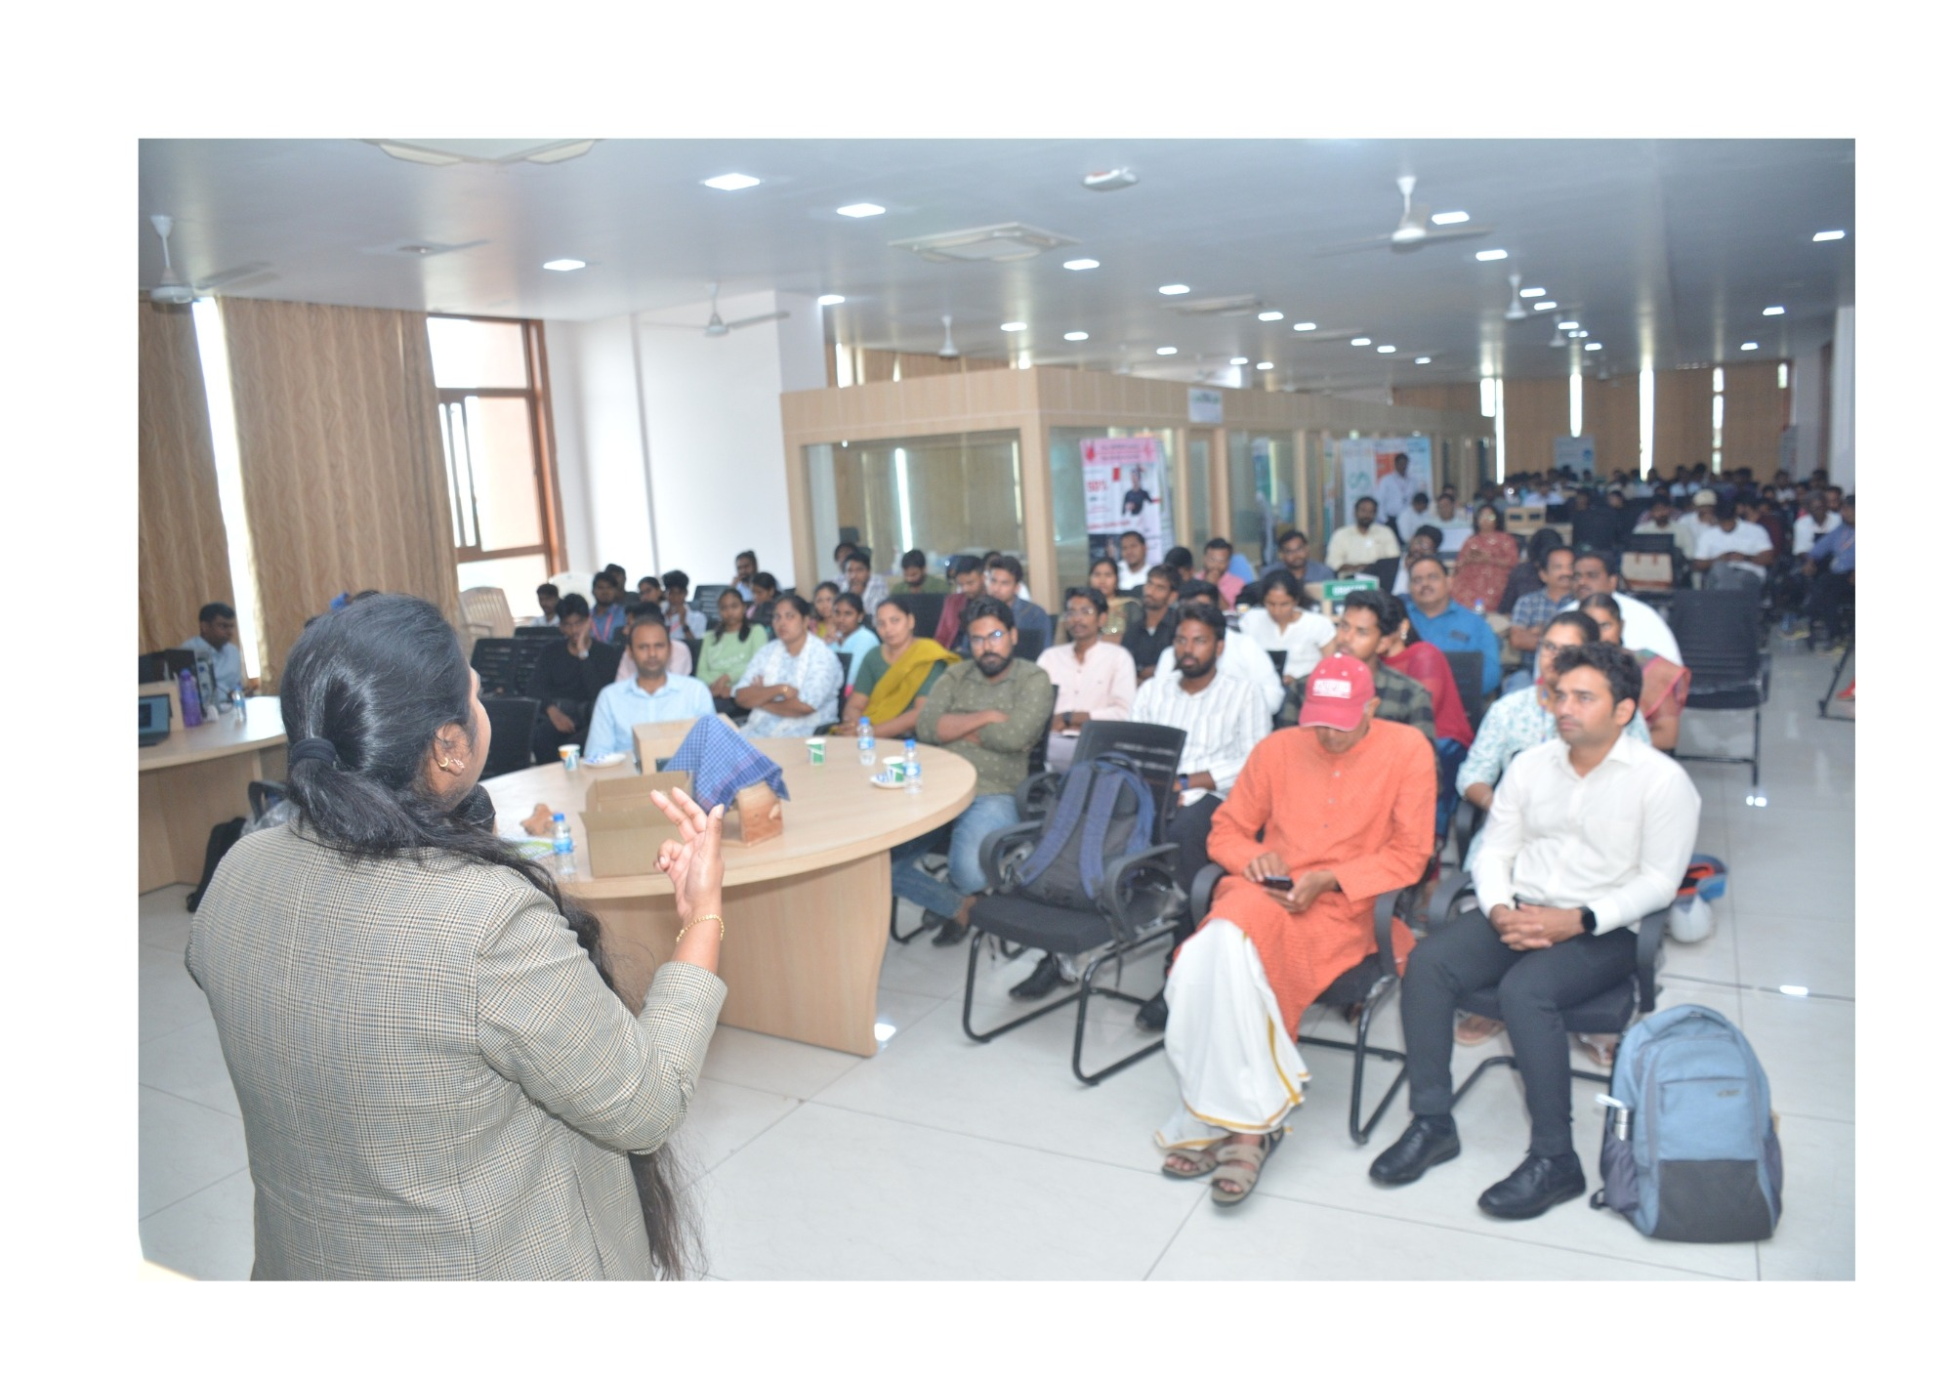
Participants engaged in the Kotak BizLabs Roadshow at Vignan TBI.
Overall Outcome: The roadshow strengthened awareness of the Kotak BizLabs Accelerator Programme among the startup ecosystem connected with Vignan TBI. It introduced founders to potential grant support of up to ₹15 lakh, investor network access and market connections, while highlighting priority sectors for innovation. The event also reinforced Vignan TBI Council’s role as an ecosystem connector, helping startups learn about external programmes and engage with organisations that support entrepreneurship and business growth.

8. Conclusion
The Kotak BizLabs Accelerator Programme Roadshow in Amaravati on 31 January 2025 introduced the startup community to an accelerator initiative focused on grants, investor networks and market access. By presenting its focus sectors and support opportunities, the programme strengthened awareness of external resources that may assist eligible startups in their development. The event also reflected the value of collaboration among Kotak BizLabs, T-Hub and Vignan TBI in connecting entrepreneurs with wider startup ecosystem opportunities.
VIGNAN TBI COUNCIL • CONNECTING STARTUPS • ENABLING OPPORTUNITY

